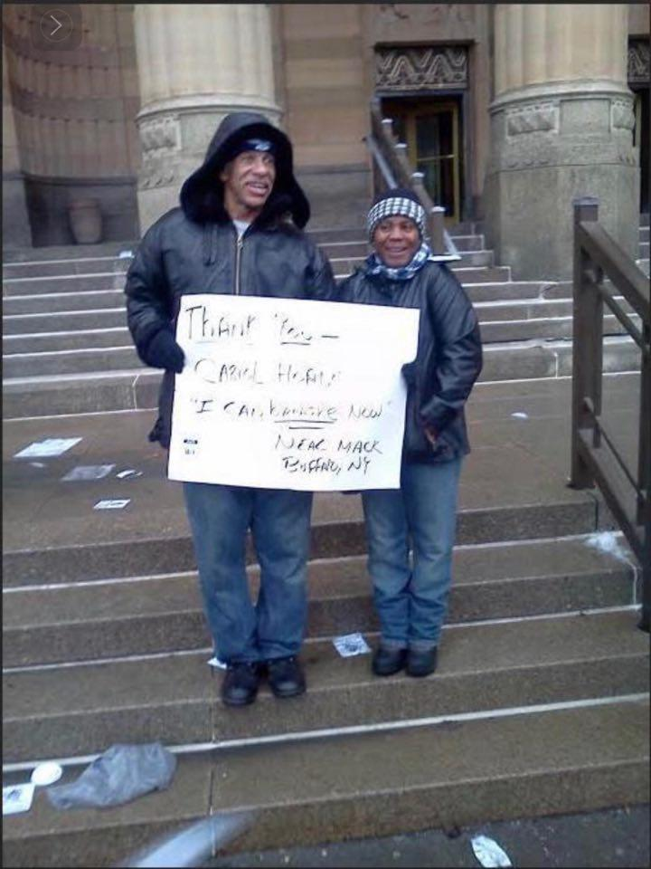  CARIOL’S LAW  Protecting police officers from retaliation when they interrupt police brutality. | Authors:  Terry Watson  Cariol Horne

Items of Cariol’s Law

This document is a short version of Cariol's Law. The extended version states definitions and terms. More information can be found at www.cariolslaw.com

Section 1: DUTY TO INTERVENE
A mandatory statute requiring Law Enforcement Professionals [LEP], either on or off duty, to intervene [until the threat is neutalized] and stops imminent abuse being performed by fellow law enforcement professionals regardless of the potential significance of injury or death to a citizen or action.

Under Section 1, C
All sworn [LEP] present at the scene in an instance where intervention by a sworn [LEP] is necessary to stop the inappropriate use of force by a fellow employee will file a report with their direct supervisor immediately following the resolution of the incident detailing what they saw take place.

Section 2: PUNISHMENTS FOR OFFICERS WHO NEGLECT THEIR DUTY TO INTERVENE
Any [LEP] who fails to intervene will be subject to criminal reprehension and termination.

Section 3: PROTECTIONS FOR OFFICERS WHO INTERVENE
A [LEP] who performs duties in good faith by interrupting the physical abuse of a person being apprehended will be protected from retaliation, abuse, or reassignment once the incident is reported. An agency external to the department will investigate reports of retaliation, abuse, or reassignment due to preventative actions listed in Section 1. Retaliation against whistleblower [LEP] or Good Samaritans who interrupt police misconduct will be grounds for employment termination.

Section 4: PUNISHMENTS FOR [LEP] WHO FALSIFY REPORTS
Any [LEP] identified through investigation (externally or internally) to have purposely fabricated, condoned or covered up through reporting or abstinence of reporting abuse/misconduct towards citizens;

Or

Any [LEP] to have fabricated or condoned actions of retaliation towards an identified [LEP] through reporting or abstinence of reporting is immediately subject to reprimand, criminal charges, termination, and is deemed not employable with any department within that state under Cariol's Law.

Section 5: POLICIES REGARDING OFFICERS WHO ARE TERMINATED AND DEPARTMENT FUNDING
A representative from Cariol's Law must be a part of the next collective bargaining agreement in which Sections 1 -4 have been violated, whereas the agency is pending investigation. Failure to have a representative of Cariol's Law will result in the loss of State funding.
Any law enforcement professional that has been terminated under Cariol's Law must have their name submitted and terms of termination listed in Cariol's Law registry.

Section 6. RETROACTIVE WHISTLEBLOWER PROTECTIONS
In keeping with the spirit of this law, [LEP] who acted in the terms under Section 1, and were terminated; thus, the twenty-year period preceding the date of adoption of this law may have pension benefits reinstated as a result of this law.

History of Cariol Horne
Cariol Horne served Buffalo, New York, as a police officer for twenty years before being fired for stopping a fellow police officer from choking a handcuffed African American man during an arrest. During this encounter, Officer Horne was physically assaulted by her fellow officer, who had a physical and psychological impact. Officer Horne speaks of how PTSD has interrupted her life since this incident and how speaking out has impacted her livelihood.

Officer Cariol Horne was unjustly fired because she dared to intervene in stopping her co-worker, Officer Kwiatkowski, from assaulting a cuffed suspect and violating a suspect’s rights. Officer Kwiatkowski later went to federal prison after pleading guilty to unlawful unnecessary force. We need laws to protect Officers like Cariol Horne, not Officer Kwiatkowski
More about Cariol Horne can be found at http://cariolhorne.com/

The Problem
On May 25, 2020, the country was shaken by the killing of George Floyd by former police Officer Derek Chauvin. The blatant disregard for human life was traumatizing. There are significant observations that warrant intervention in the protocol. Officer Chauvin was supported by three fellow officers, none intervened resulting in the death of Mr. Floyd. officers when present, are responsible for the safety and well-being of all citizens, including those in police custody. All of the officers had the opportunity to intervene as the citizen was cuffed and, on the ground, but they did not. Trained officers are empowered to preserve life and should be encouraged to intervene without the fear of retaliation. Prevention is possible, saving the life of a suspect in custody is the duty and responsibility of the police.

The Solution
This law will empower law enforcement professionals to intervene, without fear of retaliation or termination.
- We must support all law enforcement professionals who stand up for the rights and the safety of the people they protect and serve.
- We must create an environment in which police brutality is shunned and police heroism is respected.
- We must restore and/or strengthen the relationship between police and the community’s they patrol
- We must preserve and protect law enforcement professionals’ mental health and reduce the trauma experienced in the line of duty caused by fellow officers.

